How Do I Change My Syllabus?
The official syllabus for each course taught at Tri-County is contained in the College’s Curriculum Management System, WIDS. When posting or distributing your syllabus to students, please use the official document from WIDS. The syllabus contains elements that are the same for all sections of a course no matter the instructor. Those elements include Course Prefix & Number, Course Title, Course Description including Prerequisites/Co-requisites, Career Cluster, Total credits, Total hours, Type of Instruction, (Lecture/Laboratory), Instructional Level (Transfer Course, Non-Transfer Course), Grading Scale, Textbooks, Bibliography, Learner Supplies, Guidelines, Course Fees & Amount, Related Outcomes (General Education, Program, External Standards), Competencies, Competency Assessment Tasks, Competency Assessment Task Criteria, and Grading Scale. Any additional information that is specific to your course that you want to supply to your students should be distributed in the form of an addendum to the syllabus. Please verify that no information distributed contradicts any information in the official syllabus.
Each semester you may need to update your syllabus based on changes you have made to your course. You may change information related to your textbook(s), bibliography, learner supplies, and guidelines (e.g. course outline, grading rationale, or other information if the information is common to all sections of the course). All other changes require approval.
To change your syllabus go to http://tctc.wids.org
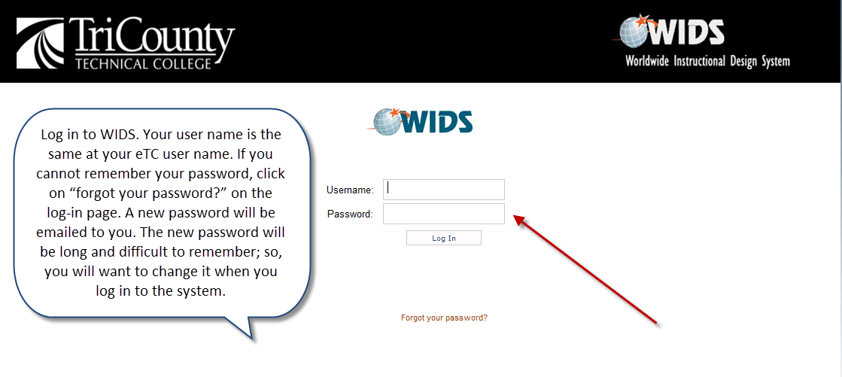

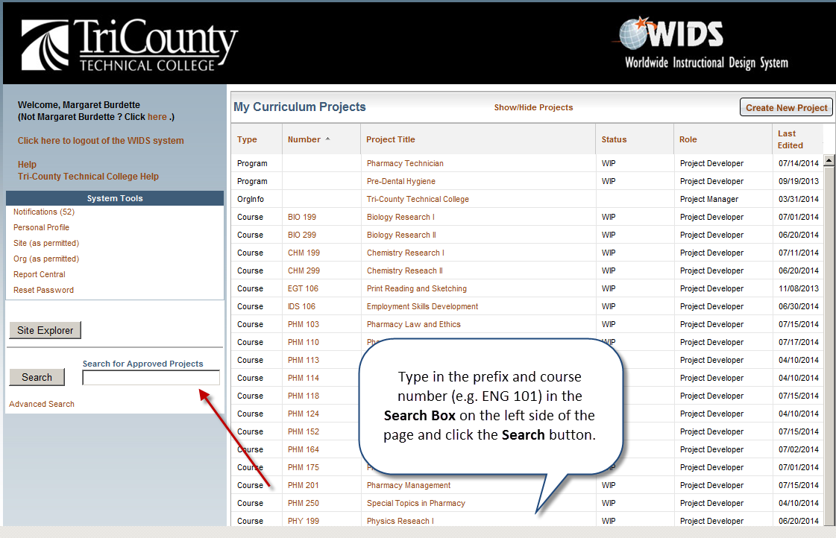
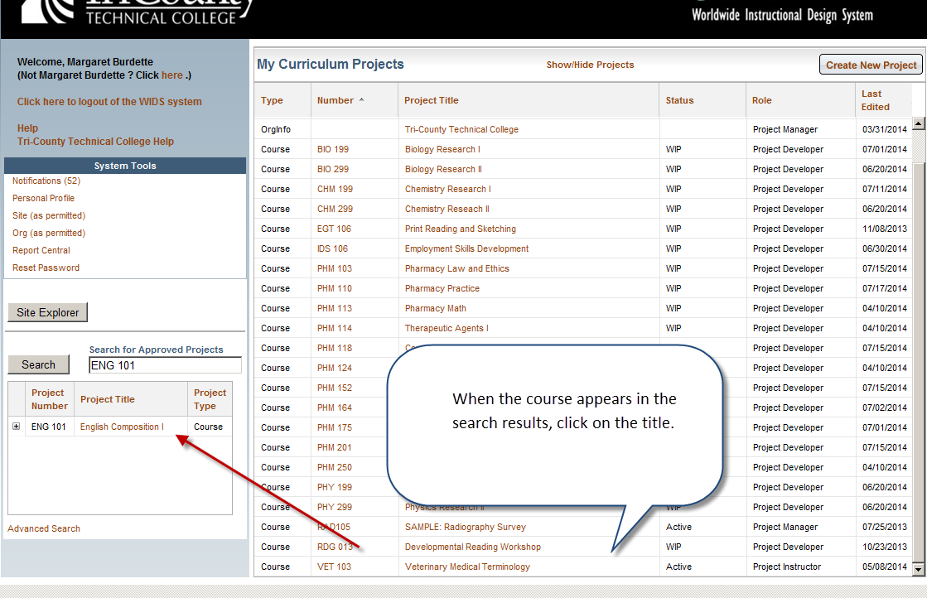
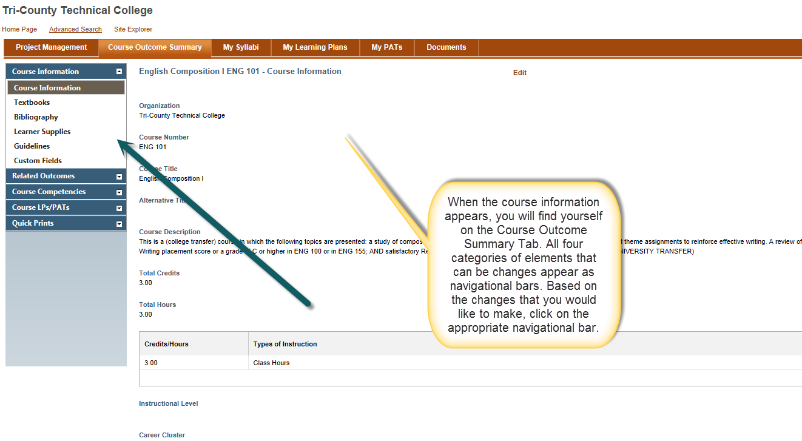
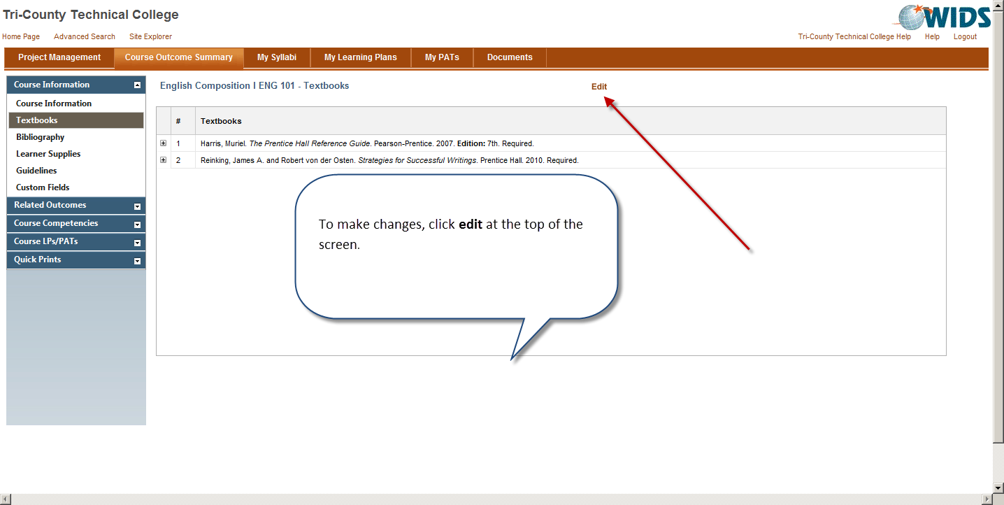

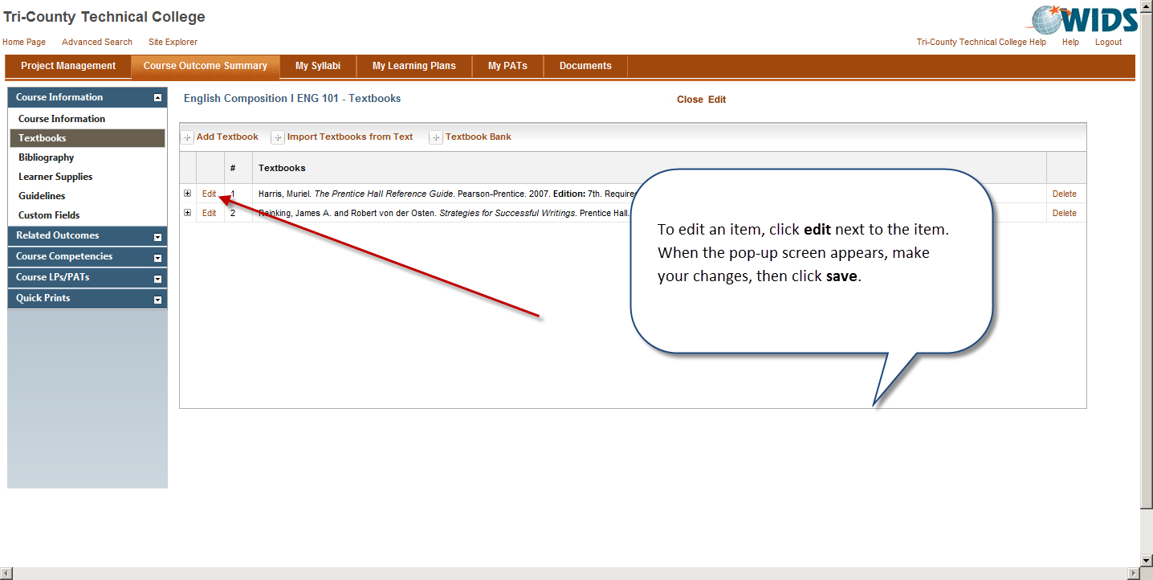

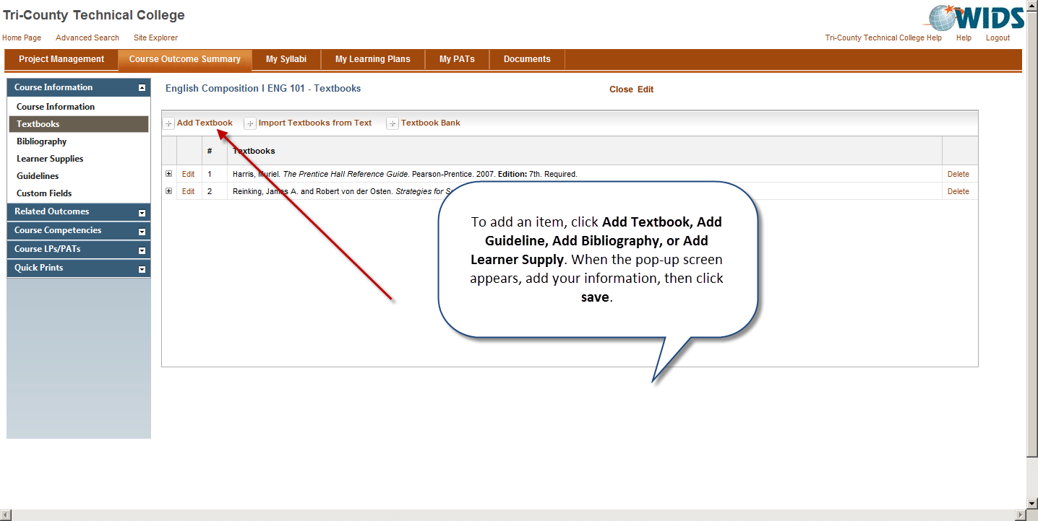

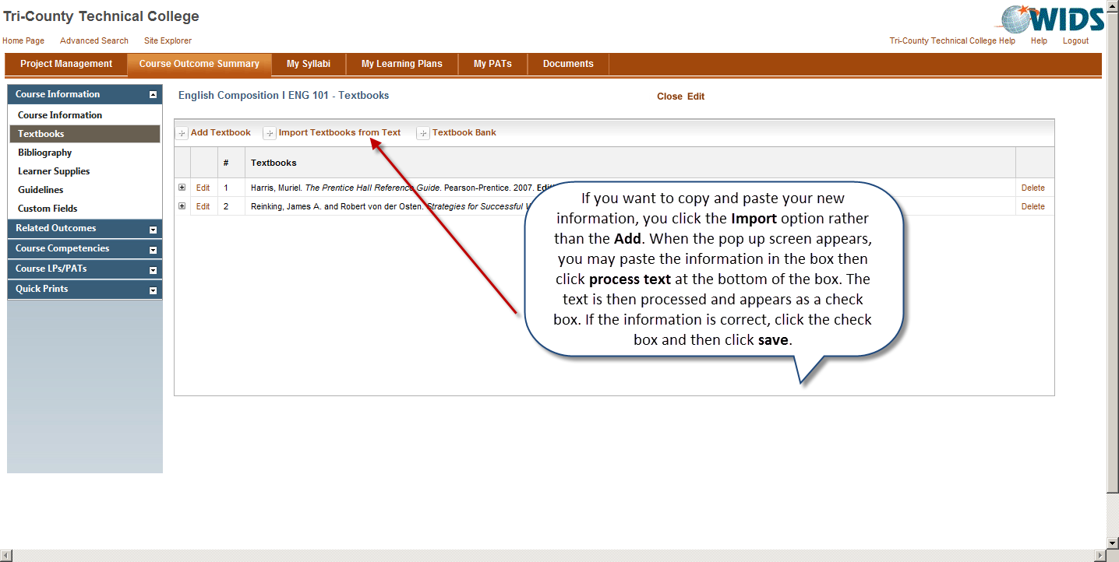
If you need assistance with this process, please contact Margaret Burdette (mburdett/1814)

